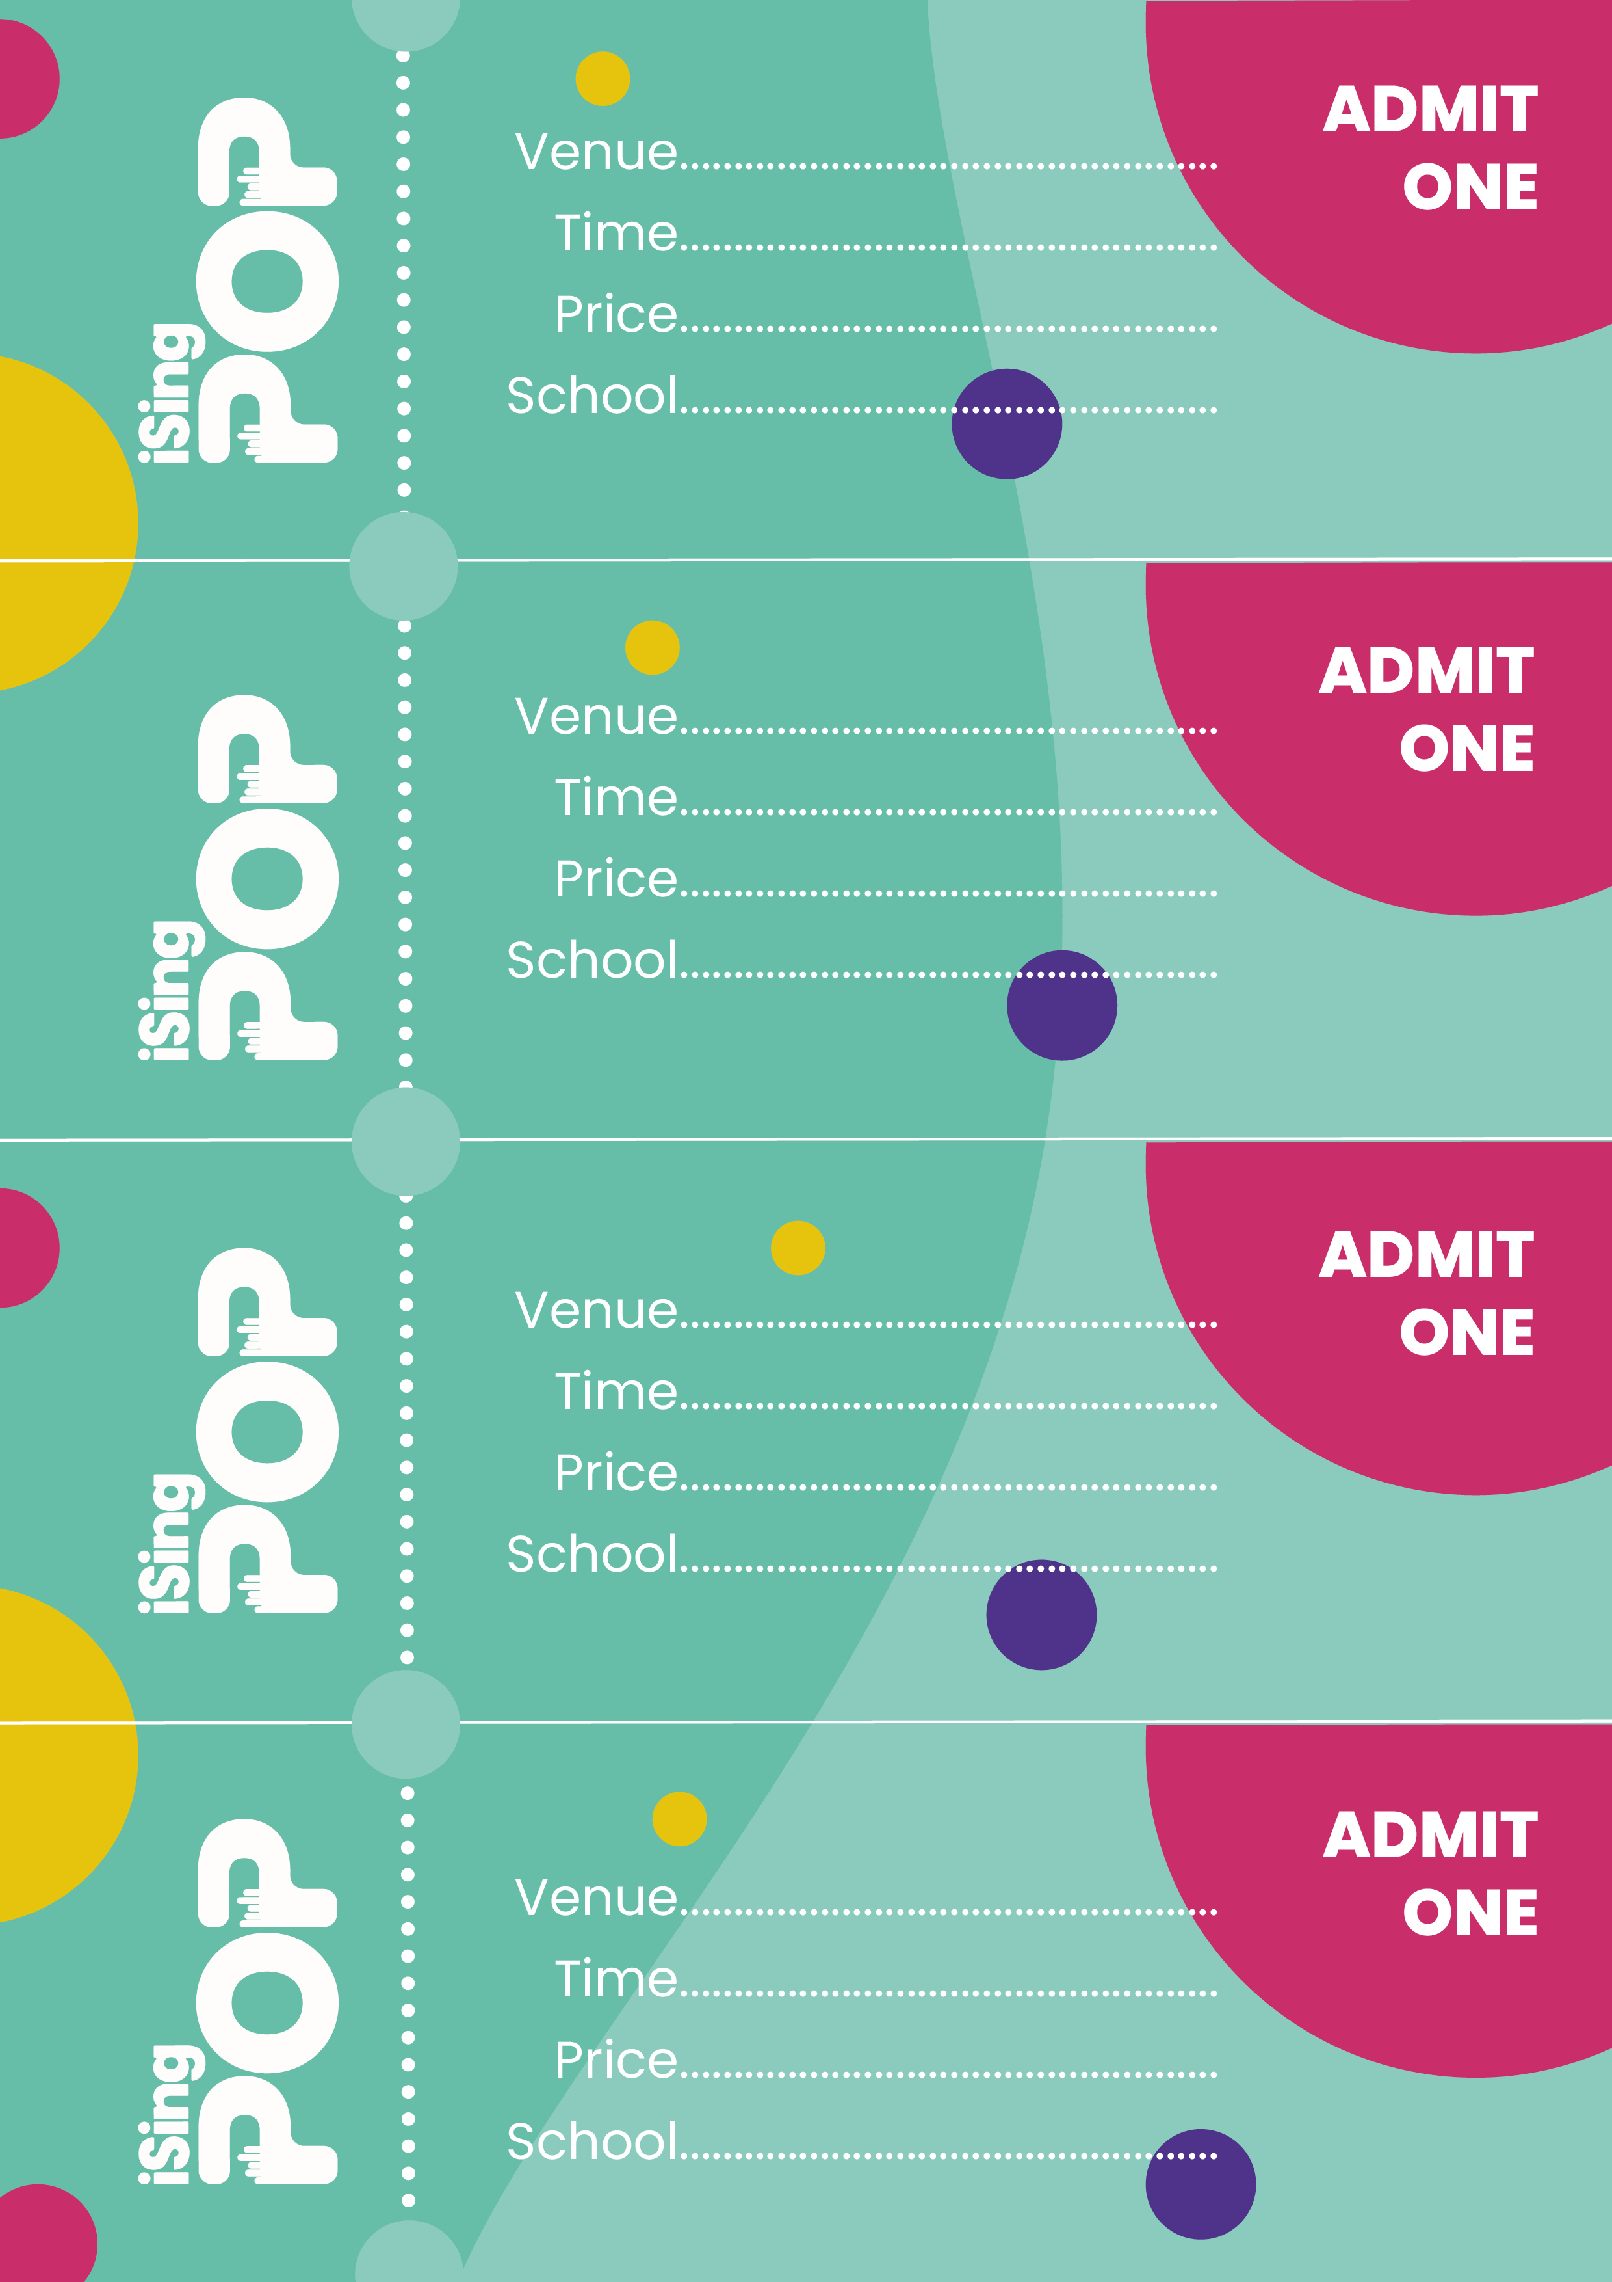
St Examples Church
2pm & 6pm
FREE
St Examples CE Primary
y
St Examples Church
2pm & 6pm
FREE
St Examples CE Primary
y
St Examples Church
2pm & 6pm
FREE
St Examples CE Primary
y
St Examples Church
2pm & 6pm
FREE
St Examples CE Primary
y

